**990 EVO Plus Gen4 NVMeᵀᴹ SSD 1TB**

MZ-V9S1T0 / MZ-V9S1T0B/AM

|

4.9 out of 5 stars, average rating value. Read 44 Reviews. Same page link.

4.9

(44)

Write a review

Total**$84.99**  
~~$109.99~~   **Save $25.00**

Add to cart

* **Overview**
* **Specs**
* **Reviews**

**Chat with an Expert**

**Chat with an Expert**

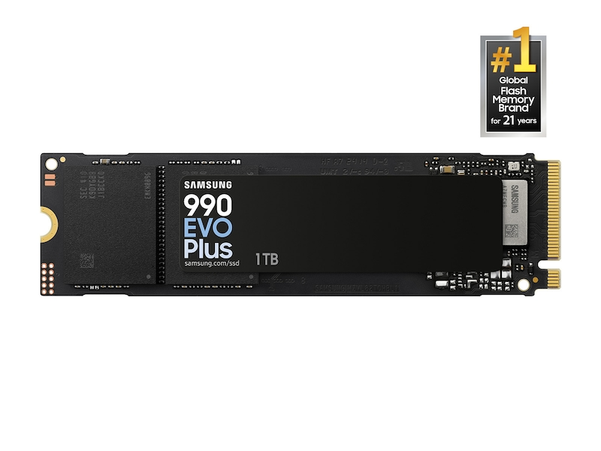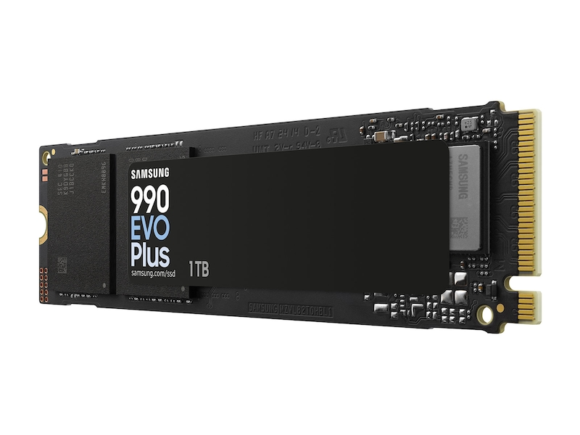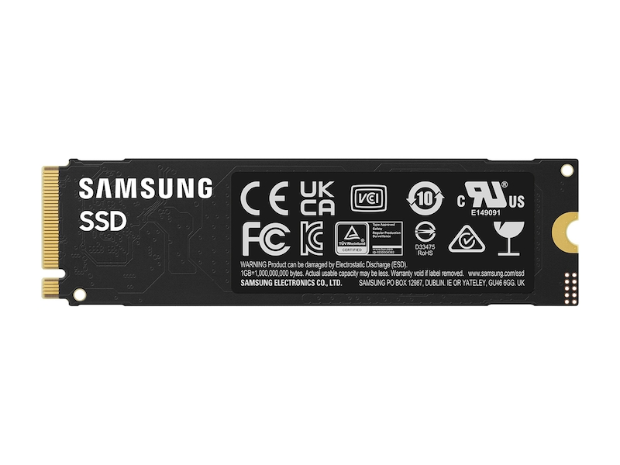

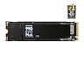

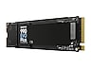

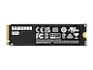

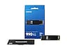

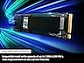



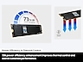





**Samsung.com Advantage**



**Pay in 4 installments**

**Free, No Contact Delivery**

**Key Features**

Up to 4TB

Sequential Read Speed up to 7,250 MB/s

Sequential Write Speed up to 6,300 MB/s

Performance Optimization

• The 990 EVO Plus brings boosted sequential read/write speeds up to 7,250/6,300MB/s.¹  
  
• Harness the full power of your drive with the enhanced large-file performance of Intelligent TurboWrite 2.0—now available in 4TB capacity.  
  
• Keep your cool as you work—or play—with no worries about overheating or battery life, thanks to an efficiency-boosting nickel-coated controller.  
  
• Optimized to support the latest technology for SSDs—990 EVO Plus is compatible with PCIe 4.0 x4 and PCIe 5.0 x2.  
  
• It’s not hocus-pocus. Your 990 EVO Plus SSD performs like new with the always up-to-date Magician Software.

Storage

**4TB**

$239.99- Current Price~~$344.99- original price~~

**Save $105.00**

**2TB**

$139.99- Current Price~~$184.99- original price~~

**Save $45.00**

**1TB**

$84.99- Current Price~~$109.99- original price~~

**Save $25.00**

**VIP Advantage**

**VIP Advantage membershipLearn more**

* 2 Year Samsung Care+ (without Theft and Loss)
* Exclusive Discounts & Early Access

To select this option, please sign in or create a Samsung account

**Premium Benefits**

**$149.99/yr**

**Delivery & professional services**

Availability for:

96928

Delivery

**Delivery**

Not available

This product is currently not available in your area.

**Choose your purchase option**

Questions? Ask a Financing Expert

**One-time Payment**

**$84.99**

**Pay in 4 Installments**

**$21.25**

**every two weeks σπ**

**One-time payment**

Pay with your credit card, debit card or a pay app. Excludes taxes and shipping.

**990 EVO Plus Gen4 NVMeᵀᴹ SSD 1TB$84.99**

**Total**

**$84.99~~$109.99- original price~~**

**You Saved Today$25.00**

**Add to cart**

[**Where to buy**](https://www.samsung.com/us/computing/memory-storage/solid-state-drives/990-evo-plus-gen5-pcie-nvmetm-ssd-1tb-mz-v9s1t0b-am-buy)

Supported payment types:

adyen_cardsPayPal Venmo Checkoutamazonpaygooglepay

**Top 3 features**



Performance

The 990 EVO Plus brings boosted sequential read/write speeds up to 7,250/6,300MB/s¹.



Versatility

Harness the full power of your drive with the enhanced large-file performance of Intelligent TurboWrite 2.0—now available in 4TB capacity.



Power efficiency

Keep your cool as you work—or play—with no worries about overheating or battery life, thanks to an efficiency-boosting nickel-coated controller.

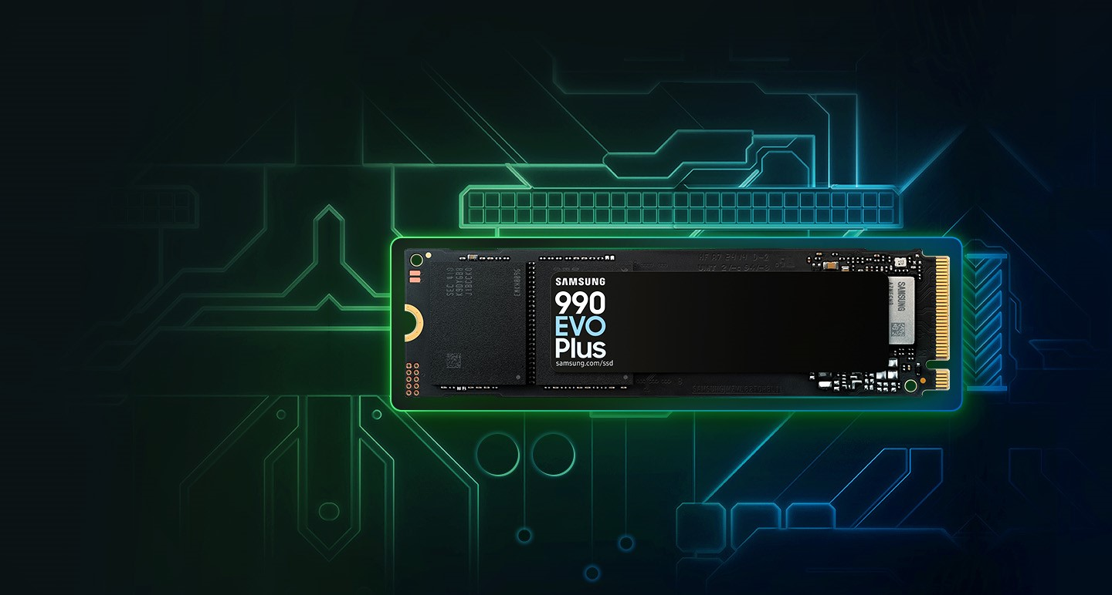

**Faster Performance. Massive Storage**

With faster read/write speeds, larger storage capacity and more efficient power/thermal control than the 990 EVO¹, the 990 EVO Plus is the perfect productivity boost to help you tackle a busy day.